**Project Development Phase**

**Project Development Delivery of Sprint 4**

|  |  |
| --- | --- |
| Date | 19 November 2022 |
| Team ID | PNT2022TMID24784 |
| Project Name | Project - Signs with smart connectivity for Better road safety |
| Marks | 8 Marks |

**Signs with smart connectivity for Better road safety Objective :**

>> Write a python code for print the random temperature, Road signs, Speed limit, Message

>> Simulate and Generate the data

>> Display the published data in IBM Watson IOT Platform

>> Connecting the Node-Red and OpenWeatherMap (Ex., Salem, IN)

>> Signs with smart connectivity for better road safety Project in Node-Red >> Test cases in UI web page

**Code for print the random temperature, Road signs, Speed limit, Message :**

# ( RandomValues.py )

import wiotp.sdk.device import time import random

import ibmiotf.application import ibmiotf.device import requests, json

myConfig = { #Configuration

"identity": {

"orgId": "e5yuue",

"typeId": "arduino",

"deviceId":"123"

},

#API Key

"auth": {

"token": "1234567890"

}

}

#Receiving callbacks from IBM IOT platform def myCommandCallback(cmd): print("Message received from IBM IoT Platform: %s" % cmd.data['command']) m=cmd.data['command']

client = wiotp.sdk.device.DeviceClient(config=myConfig, logHandlers=None) client.connect()

#OpenWeatherMap Credentials

BASE_URL = "https://api.openweathermap.org/data/2.5/weather?"

CITY = "Salem, IN"

URL = BASE_URL + "q=" + CITY + "&units=metric"+"&appid=" + "f58e4720c739a54c439aba9b05176839"

while True: response = requests.get(URL) if response.status_code == 200:

data = response.json() main = data['main'] temperature = main['temp'] humidity = main['humidity'] pressure = main['pressure'] report = data['visibility']

#messge part msg=random.randint(0,5) if msg==1:

message="GO SLOW, SCHOOL ZONE AHEAD" elif msg==2:

message="NEED HELP, POLICE STATION AHEAD" elif msg==3:

message="EMERGENCY, HOSPITAL NEARBY" elif msg==4:

message="DINE IN, RESTAURENT AVAILABLE" elif msg==5: message="PETROL BUNK NEARBY" else: message=""

#Speed Limit part speed=random.randint(0,150) if speed>=100: speedMsg=" Limit Exceeded" elif speed>=60 and speed<100:

speedMsg="Moderate" else: speedMsg="Slow"

#Diversion part sign=random.randint(0,5) if sign==1:

signMsg="Right Diversion" elif sign==2:

signMsg="Speed Breaker" elif sign==3:

signMsg="Left Diversion" elif sign==4:

signmsg="U Turn"

else:

signMsg=""

#Visibility if temperature < 24:

visibility="Fog Ahead, Drive Slow" elif temperature < 20:

visibility="Bad Weather" else:

visibility="Clear Weather" else:

print("Error in the HTTP request")

myData={'Temperature':temperature, 'Message':message, 'Sign':signMsg, 'Speed':speedMsg,

'Visibility':visibility} client.publishEvent(eventId="status", msgFormat="json", data=myData, qos=0, onPublish=None)

#PUBLISHING TO IOT WATSON print("Published data Successfully: ", myData)

print("------------------------------------------------------------------------------------

----------------------------------------------------------------------------------------------

------------------------------------------") client.commandCallback = myCommandCallback time.sleep(5) client.disconnect()

**Import wiotp-sdk & ibmiotf :**

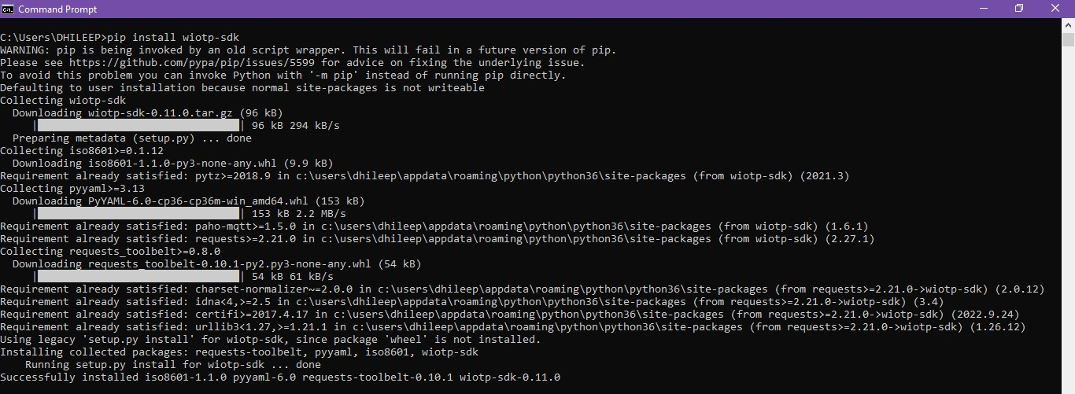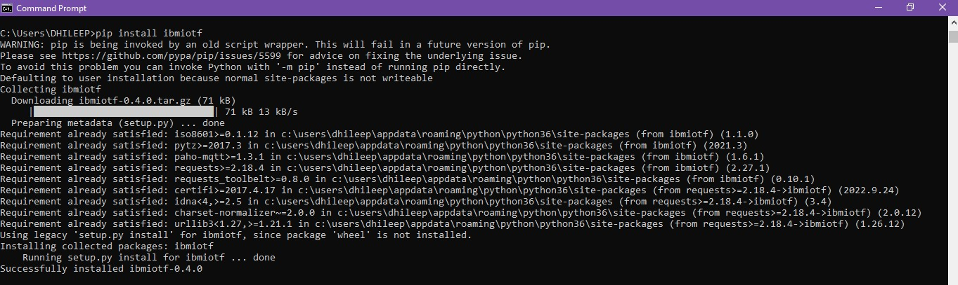

**OpenWeatherMap - (Ex., Salem, IN) :**

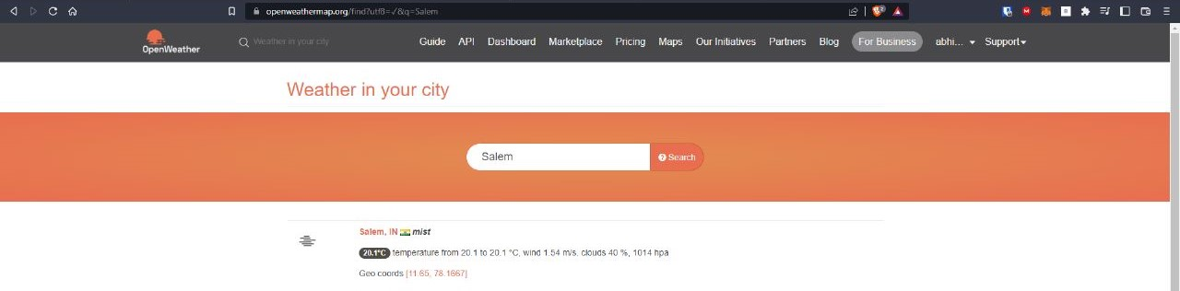

**Python IDLE Output :**

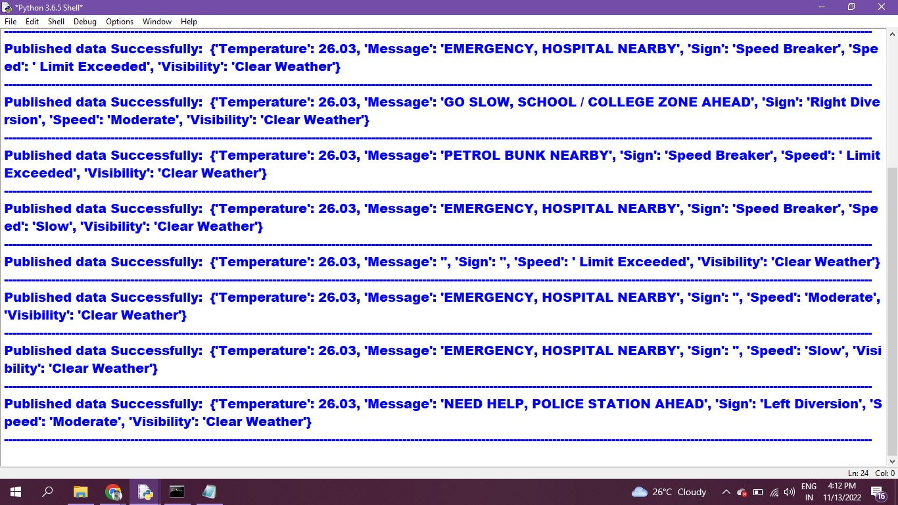

**IBM Watson IOT Platform :**

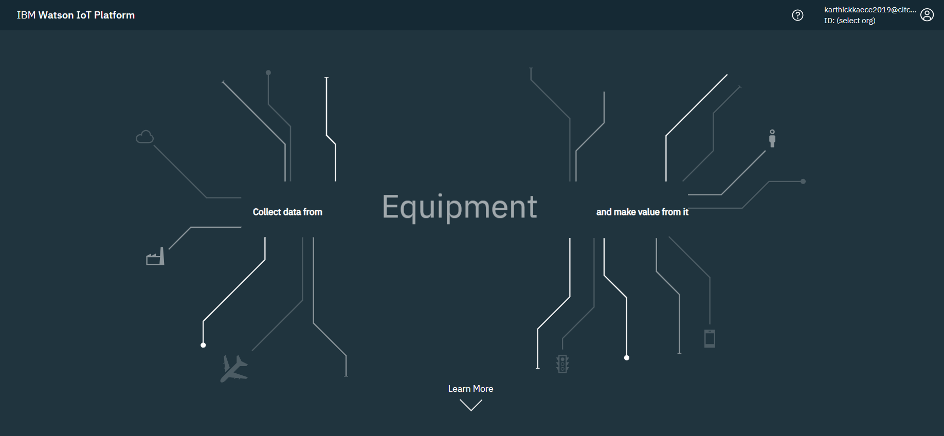

**IBM Watson IOT Platform - Device Creation :**

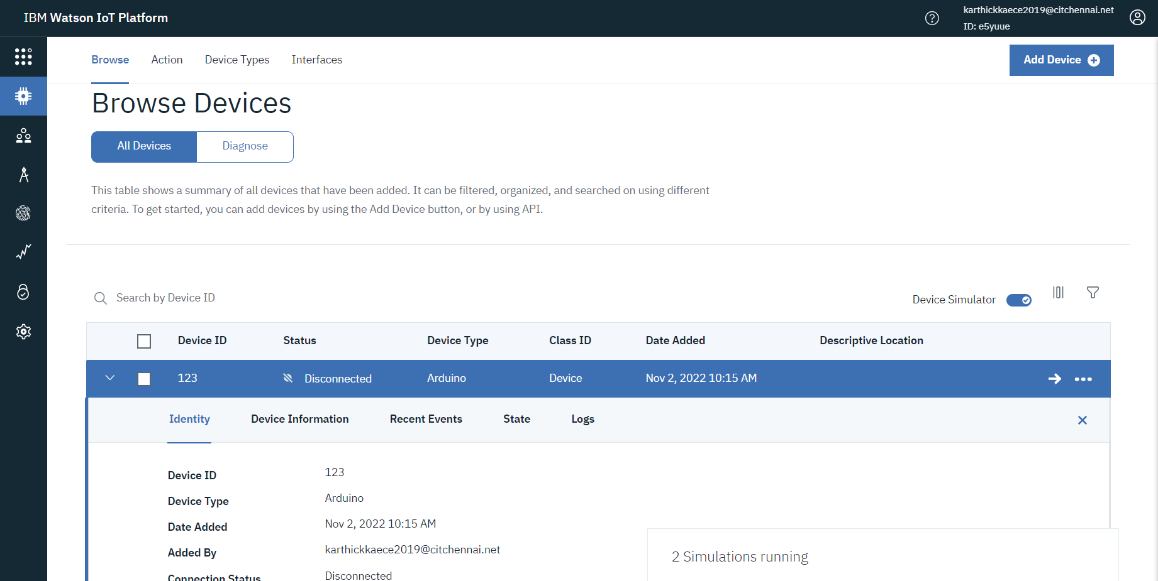

**Connecting the Node-Red and OpenWeatherMap (Ex., Salem, IN) :**

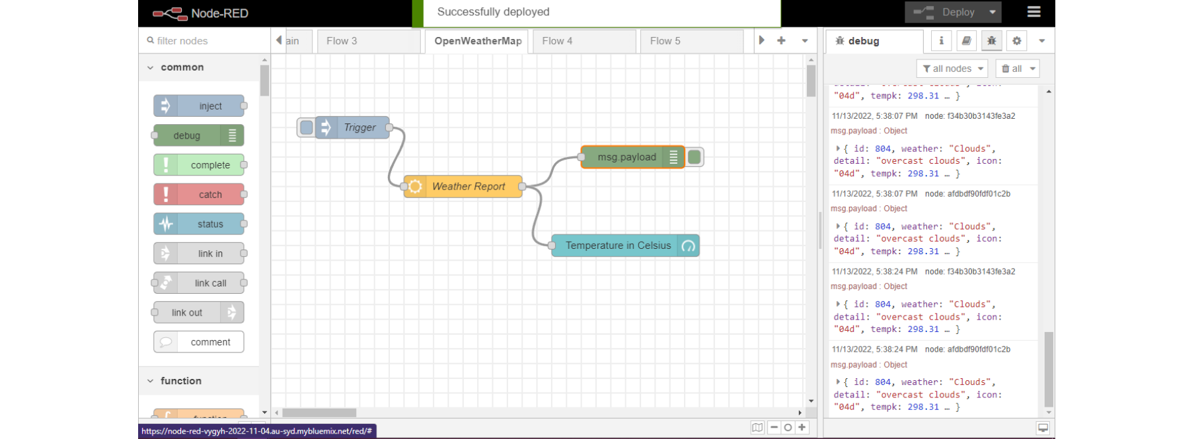

**Signs with smart connectivity for better road safety - Node-Red :**

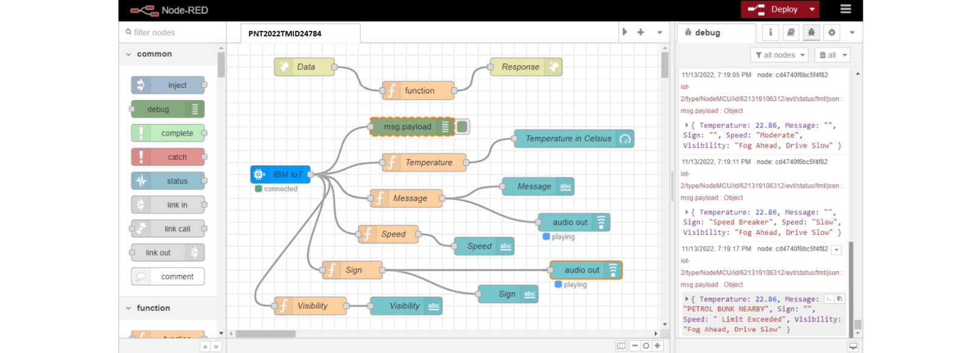

**Test Case - 1 :**

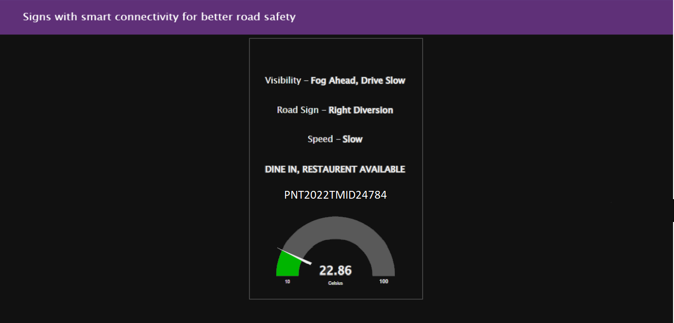

**Test Case - 2 :** 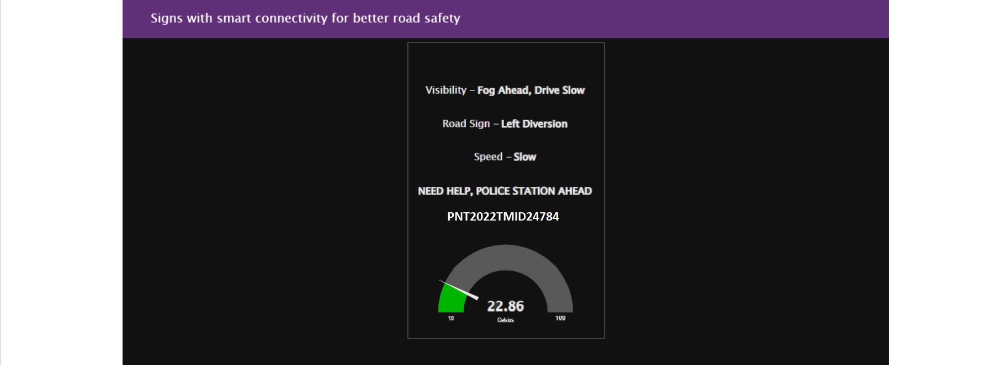

**Test Case - 3 :**

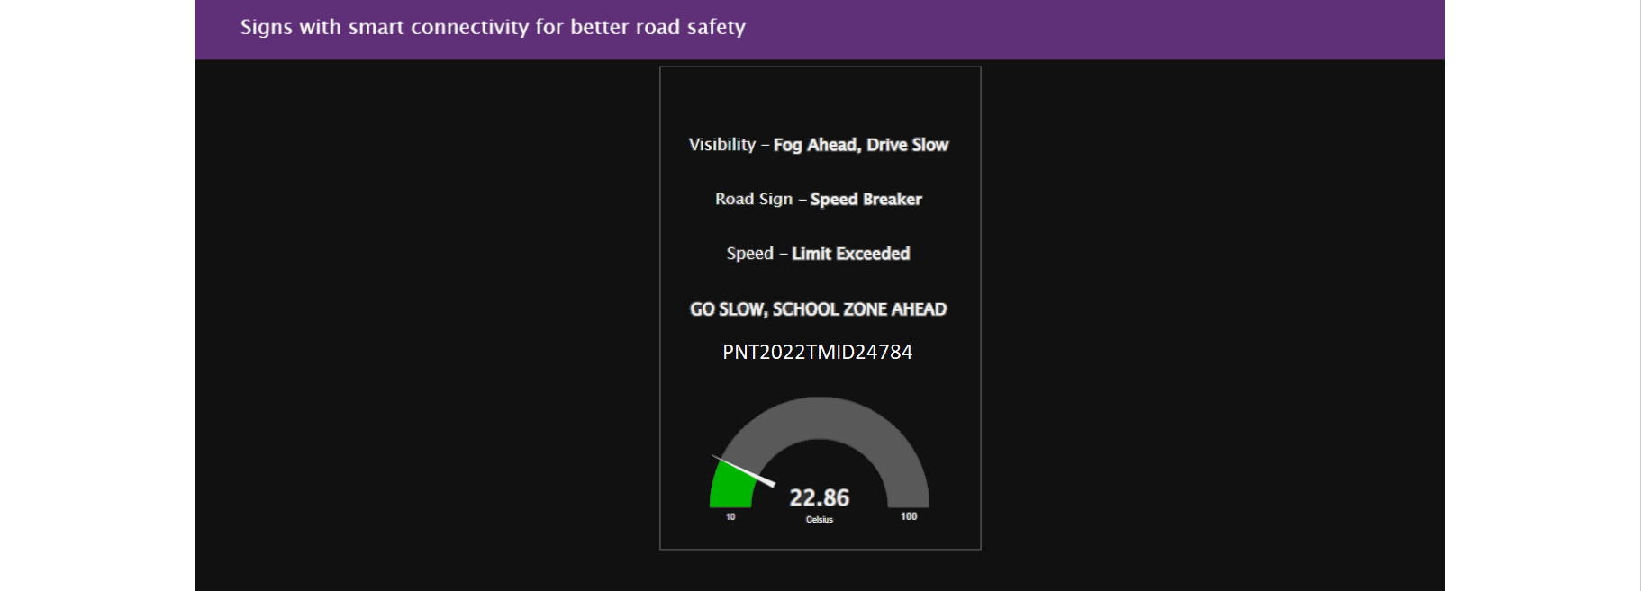

**Test Case - 4 :**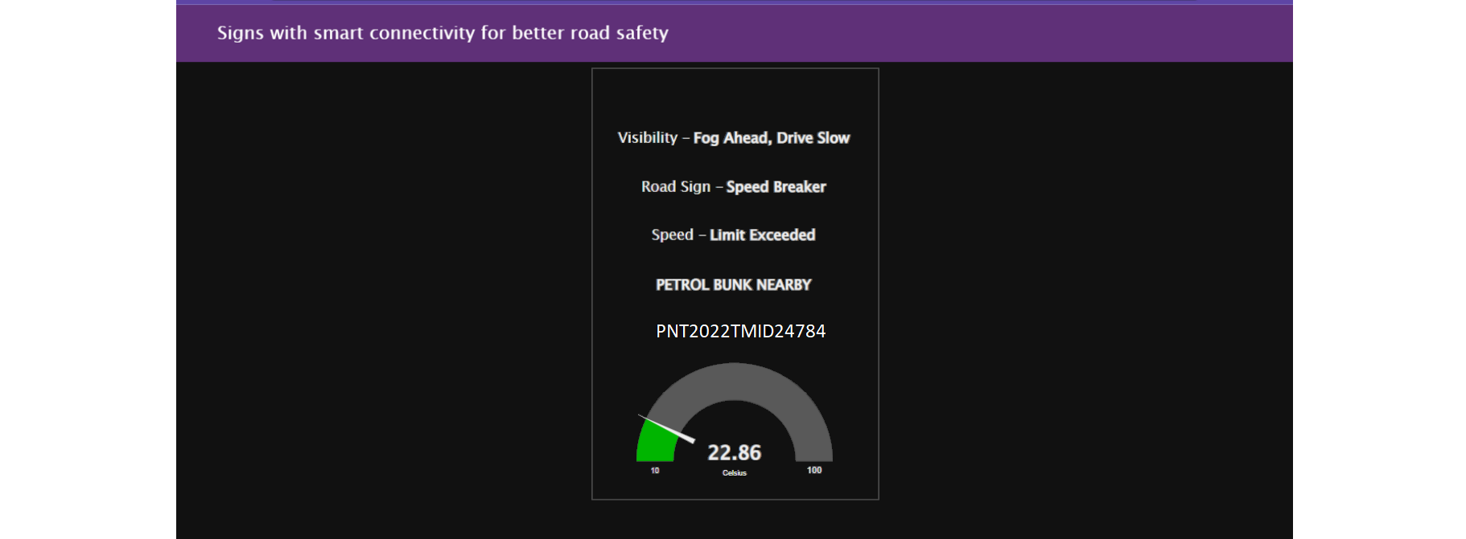

**Test Case - 5 :**

